# Sample Social Media Posts

We’ve created sample social media posts to make it easy for you to share information about Let’s Talk with your district and community.

|  |  |
| --- | --- |
| **LinkedIn and Facebook** | **Twitter (X)** |
| Have a question, need information, or want to share feedback?  We’re excited to introduce Let’s Talk, our new districtwide customer service platform that makes it easier than ever to get the answers and information you need, quickly and conveniently.  Reach out to us through Let’s Talk today!  [Insert URL for district’s Let’s Talk landing page] | Have a question or want to share feedback?  Introducing Let’s Talk, our new districtwide customer service platform that makes it easier than ever to get the answers and information you need, quickly and conveniently.  Reach out to us through Let’s Talk today!  [Insert URL for district’s Let’s Talk landing page] |
| We’re thrilled to introduce Let’s Talk, our districtwide customer service platform that makes it easy for you to submit questions or feedback and receive timely responses.  Reach out anytime, anywhere for quick, accurate answers 24/7 from any device.  [Insert URL for district’s Let’s Talk landing page] | We’re thrilled to introduce Let’s Talk, our districtwide customer service platform that makes it easy for you to submit questions or feedback and receive timely responses.  Reach out anytime, anywhere for quick, accurate answers 24/7 from any device.  [Insert URL for district’s Let’s Talk landing page] |

|  |  |
| --- | --- |
| **LinkedIn and Facebook** | **Twitter (X)** |
| We’re excited to introduce Let’s Talk to the [District Name] community — our districtwide customer service platform built for you.  With Let’s Talk, you can:   * Ask questions and share feedback * Access support 24/7 from any device * Receive timely, accurate responses every time   [Insert URL for district’s Let’s Talk landing page] | We’re excited to introduce Let’s Talk to the [District Name] community — our districtwide customer service platform built for you.  With Let’s Talk, you can:   * Ask questions and share feedback * Access support 24/7 from any device * Receive timely, accurate responses every time   [Insert URL for district’s Let’s Talk landing page] |
| Have a question about back-to-school or safety protocols? Want to learn about volunteer opportunities?  Get timely, accurate answers with Let’s Talk — our district’s dedicated customer service platform.  [Insert URL for district’s Let’s Talk landing page] | Have a question about back-to-school or safety protocols? Want to learn about volunteer opportunities?  Get timely, accurate answers with Let’s Talk — our district’s dedicated customer service platform.  [Insert URL for district’s Let’s Talk landing page] |
| Got questions? Now, there’s a new way to get the information you need quickly and conveniently.  Introducing Let’s Talk — our new districtwide customer service platform that makes it easier than ever to connect with [District Name] schools.  [Insert URL for district’s Let’s Talk landing page] | Got questions? Now, there’s a new way to get the information you need quickly and conveniently.  Introducing Let’s Talk — our new districtwide customer service platform that makes it easier than ever to connect with [District Name] schools.  [Insert URL for district’s Let’s Talk landing page] |

Need more support? Check out these example social media posts from client districts promoting Let’s Talk to their district and community.

* [**Eden Prairie Schools - Facebook Teacher Appreciation**](https://kc.k12insight.com/article/facebook-teacher-appreciation/)
* [**Craven County Schools - Facebook Landing Page Contact Us**](https://kc.k12insight.com/article/facebook-landing-page-contact-us/)
* [**Additional examples of social posts promoting Let’s Talk**](https://kc.k12insight.com/article/social-posts-flyers-magnets/)

# Sample Social Media Graphics

Click the social media graphics to download social images or use this [Canva template](https://www.canva.com/design/DAGPQqi4AwE/Pq9pnX6sTmf5nLlTQItNGw/edit) to customize your own social graphics.

**[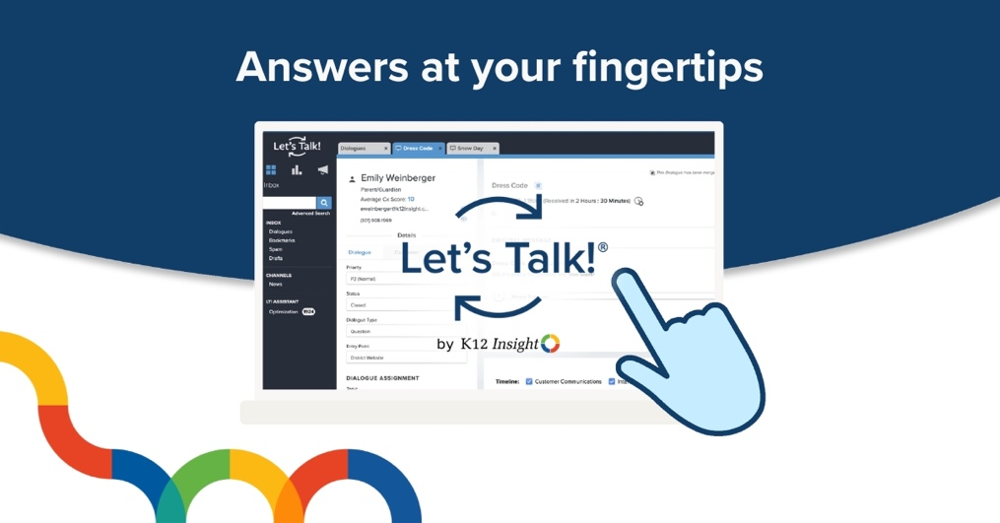](https://go.k12insight.com/hubfs/2024%20LT%20Communications%20Toolkit%20Refresh/Lets%20Talk%20social%20media%20graphic_01.jpg)  
  
[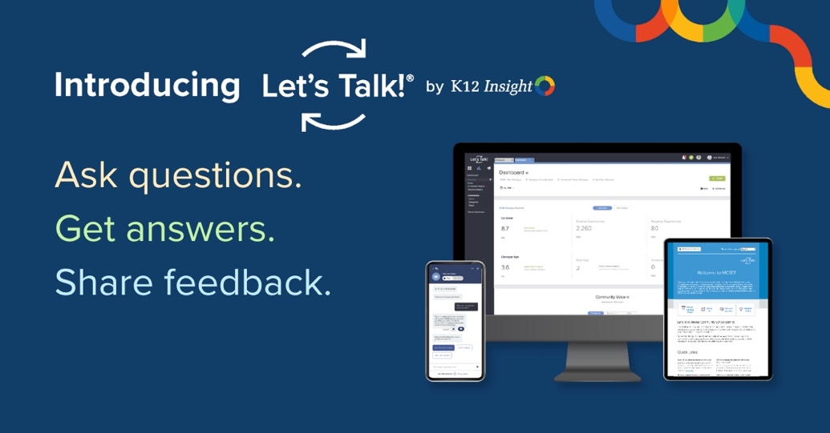](https://go.k12insight.com/hubfs/2024%20LT%20Communications%20Toolkit%20Refresh/Lets%20Talk%20social%20media%20graphic_03.jpg)  
  
[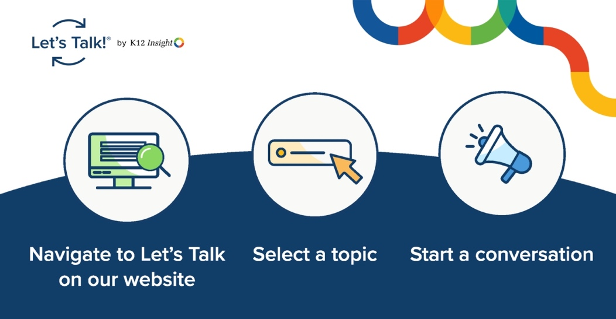](https://go.k12insight.com/hubfs/2024%20LT%20Communications%20Toolkit%20Refresh/Lets%20Talk%20social%20media%20graphic_02.jpg)**